CHAPTER-1

1. INTRODUCTION

1.1 OVERVIEW

The power quality problems in power system happens in millisecond and because of time limitation it requires fast operating custom devices. FACTS technology is the application of a variety of new power electronic controllers for both active and reactive power compensation. The stimulating functions of FACTS estimate the critical clearing time, voltage regulation, steady state power flow and oscillation damping control.

The insertion of such controllers in power system enables an approach to plan a better reactive power management scheme which improves voltage profile, utilizes the existing transmission system assets, increases transmission system reliability, amplifies transient grid stability and reduces loop flow. Highly adaptable, efficient FACTS controllers exist that are rapidly emerging in power systems and includes Static Synchronous compensator - STATCOM, Static Series Compensator- SSSC and Unified Power Flow Controller (UPFC). STATCOM is a popular FACTS controller to support the voltage, improve the transmission capability, enhance the voltage stability and increase the transient stability by injecting/absorbing the reactive power to/from the power system at the point of common coupling.

Modular Multilevel converter (MMC) based STATCOM is an extended topology of STATCOM with enhanced power quality as it reduces the harmonic contamination injected by the STATCOM into the power system. The complete simulation of the Modular Multilevel Converter based STATCOM within a power system is performed in the MATLAB software and the PI control is used for the controlling. The control circuit uses PWM technique for controlling action. The MMCCs will be classified into four -star bridge cells (DSBCs). The term bridge cell is a single-phase full bridge converter, and chopper cell consisting of a dc capacitor and two IGBT. The Double - star bridge cells (DSBCs) are suitable for a Static synchronous Compensator (STATCOM) for voltage regulation problem of eliminating harmonics. The output waveform of multilevel converter is in a stepped wave form resulting in reduced harmonics compared to square wave converter.

1.2 LITRATURE REVIEW
The papers related to Modular Multilevel Inverter and STATCOM has been done to study the various methodologies used by the researchers. The power quality problems in power system happens in milliseconds it requires fast operating custom devices. To overcome this problem by using modular multilevel inverter method

The project proposed by M. Saeedifard, R. Iravani, “Dynamic Performance of a Modular Multilevel Back-to-Back HVDC System, and Xiao feng Yang, Jianghong Li, Wenbao Fan, Xiaopeng Wang, T.Q. Zheng, Research on modular multilevel converter based STATCOM, the power quality problem is done by the help of modular multilever inverter through simulations using MATLAB / SIMULINK.In which multilevel controller is designed based on STATCOM .This Project is utilizes the MATLAB SIMULINK software in the modeling of power system

The project proposed by Wei Li, Luc-André Gregoire, Jean Bélanger, Control and Performance of a Modular Multilevel Converter System “Journal of Information Technology and Applications are deals with the help of computer simulation, the entire performance of the system has been verified.

1.3 OBJECTIVE OF THE WORK
The work reported in this project has been carried out with the objective of studying the dynamic stability of FACTS controller named as STATCOM controller and its operating study with the help of voltage and current waveform the thesis is organized into five chapters. The organization of thesis is as follows: Highlights the brief overview, summary of work carried out by various researchers, the objective of the project and the outline of the project

CHAPTER-2

2.1 POWER QUALITY PROBLEMS

2.1.1 Sources and effects of power quality problems:

Power distribution systems, ideally, should provide their customers with an uninterrupted flow of energy at smooth sinusoidal voltage at the contracted magnitude level and frequency. However, in practice, power systems, especially the distribution system. Have numerous
Non-linear loads, which significantly affect the quality of power supplies. As a result of the Non-linear loads, the purity of the waveform of supplies is lost. This ends up producing many power quality problems.

While power disturbances occur on all electrical systems, the sensitivity of today’s sophisticated electronic devices makes them more susceptible to the quality of power supply. For some sensitive devices, a momentary disturbance can cause scrambled data, interrupted communications, a frozen mouse, system crashes and equipment failure etc. A power voltage spike can damage valuable components. Power Quality problems encompass a wide range of disturbances such as voltage sags/swells, flicker, harmonics distortion, impulse transient, and interruptions.

• Voltage dip: A voltage dip is used to refer to short-term reduction in voltage of less than half a second.

• Voltage sag: Voltage sags can occur at any instant of time, with amplitudes ranging from
10 – 90% and a duration lasting for half a cycle to one minute.

• Voltage swell: Voltage swell is defined as an increase in rms voltage or current at the power frequency for durations from 0.5 cycles to 1 min.

• Voltage 'spikes', 'impulses' or 'surges': These are terms used to describe abrupt, very brief increases in voltage value.

• Voltage transients: They are temporary, undesirable voltages that appear on the power supply line. Transients are high over-voltage disturbances (up to 20KV) that last for a very short time.

• Harmonics: The fundamental frequency of the AC electric power distribution system is 50 Hz. A harmonic frequency is any sinusoidal frequency, which is a multiple of the fundamental frequency. Harmonic frequencies can be even or odd multiples of the sinusoidal fundamental frequency.

• Flickers: Visual irritation and introduction of many harmonic components in the supply power and their associated ill effects.

2.1.2 Causes of dips, sags and surges:

1. Rural location remote from power source
2. Unbalanced load on a three phase system
3. Switching of heavy loads
4. Long distance from a distribution transformer with interposed loads
5. Unreliable grid systems
6. Equipments not suitable for local supply

2.1.3 Causes of transients and spikes:

1. Lightening
2. Arc welding
3. Switching on heavy or reactive equipments such as motors, transformers, motor drives
4. Electric grade switching

2.2 Standards Associated with Voltage Sags
Standards associated with voltage sags are intended to be used as reference documents Describing single components and systems in a power system. Both the manufacturers and the buyers use these standards to meet better power quality requirements.
Manufactures develop products meeting the requirements of a standard, and buyers demand from the manufactures that the product comply with the standard. The most common standards dealing with power quality are the ones issued by IEEE, IEC, CBEMA, and SEMI.

2.2.1 IEEE Standard
The Technical Committees of the IEEE societies and the Standards Coordinating Committees of IEEE Standards Board develop IEEE standards. The IEEE standards associated with voltage sags are given below.
IEEE 446-1995, “IEEE recommended practice for emergency and standby power systems for industrial and commercial applications range of sensibility loads” The standard discusses the effect of voltage sags on sensitive equipment, motor starting, etc. It shows principles and examples on how systems shall be designed to avoid voltage sags and other power quality problems when backup system operates. IEEE 493-1990, “Recommended practice for the design of reliable industrial and commercial power systems”
The standard proposes different techniques to predict voltage sag characteristics,
Magnitude, duration and frequency. There are mainly three areas of interest for voltage sags.

The different areas can be summarized as follows:
- Calculating voltage sag magnitude by calculating voltage drop at critical load with Knowledge of the network impedance, fault impedance and location of fault.
- By studying protection equipment and fault clearing time it is possible to estimate the duration of the voltage sag.
- Based on reliable data for the neighbourhood and knowledge of the system Parameters an Estimation of frequency of occurrence can be made.

IEEE 1100-1999, “IEEE recommended practice for powering and grounding Electronic
Equipment” This standard presents different monitoring criteria for voltage sags and has a chapter explaining the basics of voltage sags. It also explains the background and application of the CBEMA (ITI) curves. It is in some parts very similar to Std. 1159 but not as specific in defining

Different types of disturbances.

IEEE 1159-1995, “IEEE recommended practice for monitoring electric power quality” The purpose of this standard is to describe how to interpret and monitor electromagnetic Phenomena properly. It provides unique definitions for each type of disturbance. IEEE 1250-1995, “IEEE guide for service to equipment sensitive to momentary voltage disturbances” This standard describes the effect of voltage sags on computers and sensitive equipment Using solid-state power conversion. The primary purpose is to help identify potential problems. It also aims to suggest methods for voltage sag sensitive devices to operate safely during disturbances.
It tries to categorize the voltage-related problems that can be fixed by the utility and those which have to be addressed by the user or equipment designer. The second goal is to help designers of equipment to better understand the environment in which their devices will operate. The standard explains different causes of sags, lists of examples of sensitive loads, and offers solutions to the problems

2.2.2 SEMI International Standards

The SEMI International Standards Program is a service offered by Semiconductor Equipment and Materials International (SEMI). Its purpose is to provide the semiconductor and flat panel display industries with standards and recommendations to improve productivity and business. SEMI standards are written documents in the form of specifications, guides, test methods, terminology, and practices. The standards are voluntary technical agreements between equipment manufacturer and end-user.

The standards ensure compatibility and interoperability of goods and services. Considering voltage sags, two standards address the problem for the equipment. SEMI F47-0200, “Specification for semiconductor processing equipment voltage sag Immunity”. The standard addresses specifications for semiconductor processing equipment Voltage sag immunity. It only specifies voltage sags with duration from 50ms up to 1s. It is also limited to phase-to-phase and phase-to-neutral voltage incidents, and presents a voltage-duration graph, shown in Figure 2.2. SEMI F42-0999, “Test method for semiconductor processing equipment voltage sag immunity”

This standard defines a test methodology used to determine the susceptibility of Semiconductor processing equipment and how to qualify it against the specifications. It further describes test apparatus, test set-up, test procedure to determine the susceptibility of Semiconductor processing equipment, and finally how to report and interpret the results.

2.3 Solutions to power quality problems:

There are two approaches to the mitigation of power quality problems. The solution the power quality can be done from customer side or from utility side First approach is called load conditioning, which ensures that the equipment is less sensitive to power disturbances, allowing the operation even under significant voltage distortion. The other solution is to install line conditioning systems that suppress or counteracts the power system disturbances.
Currently they are based on PWM converters and connect to low and medium voltage distribution system in shunt or in series. Series active power filters must operate in conjunction with shunt passive filters in order to compensate load current harmonics. Shunt active power filters operate as a controllable current source and series active power filters operates as a controllable voltage source. Both schemes are implemented preferable with voltage source PWM inverters, with a dc bus having a reactive element such as a capacitor. However, with the restructuring of power sector and with shifting trend towards distributed and dispersed generation, the line conditioning systems or utility side solutions will play a major role in improving the inherent supply quality; some of the effective and economic measures can be identified as following:

Lightening and Surge Arresters:
Arresters are designed for lightening protection of transformers, but are not sufficiently. Voltage limiting for protecting sensitive electronic control circuits from voltage surges.

Thyristor Based Static Switches:
The static switch is a versatile device for switching a new element into the circuit when the voltage support is needed. It has a dynamic response time of about one cycle. To correct quickly for voltage spikes, sags or interruptions, the static switch can used to switch one or more of devices such as capacitor, filter, alternate power line, energy storage systems etc. The static switch can be used in the alternate power line applications.

Energy Storage Systems:
Storage systems can be used to protect sensitive production equipment’s from shutdowns caused by voltage sags or momentary interruptions. These are usually DC storage systems such as UPS, batteries, superconducting magnet energy storage (SMES), storage capacitors or even fly wheels driving DC generators .The output of these devices can be supplied to the system through an inverter on a momentary basis by a fast acting electronic switch. Enough energy is fed to the system to compensate for the energy that would be lost by the voltage sag or interruption.

Though there are many different methods to mitigate voltage sags and swells, but the use of a custom Power device is considered to be the most efficient method. For example, Flexible AC Transmission Systems (FACTS) for transmission systems, the term custom power pertains to the use of power electronics controllers in a distribution system, specially, to deal with various power quality problems. Just as FACTS improves the power transfer capabilities and stability margins, custom power makes sure customers get pre-specified quality and reliability of supply.

This pre-specified quality may contain a combination of specifications of the following: low Phase unbalance, no power interruptions, low flicker at the load voltage, low harmonic distortion in load voltage, magnitude and duration of overvoltage and under voltages within specified limits, acceptance of fluctuations, and poor factor loads without significant effect on the terminal voltage There are many types of Custom Power devices.

Some of these devices include:
Active Power Filters (APF), Battery Energy Storage Systems (BESS), Distribution Static synchronous Compensators (DSTATCOM), Distribution Series Capacitors (DSC), Dynamic Voltage Restorer (DVR), Surge Arresters (SA), Super conducting Magnetic Energy Systems (SMES),Static Electronic Tap Changers (SETC), Solid-State Transfer Switches (SSTS), Solid State Fault Current Limiter (SSFCL), Static Var Compensator (SVC), Thyristor Switched Capacitors (TSC),and Uninterruptible Power Supplies (UPS)

CHAPTER-3

3.FACTS
The increasing Industrialization, urbanization of life style has lead to increasing dependency on the electrical energy. This has resulted into rapid growth of power systems. This rapid growth has resulted into few uncertainties. Power disruptions and individual power outages are one of the major problems and affect the economy of any country. In contrast to the rapid changes in technologies and the power required by these technologies, transmission systems are being pushed to operate closer to their stability limits and at the same time reaching their thermal limits due to the fact that the delivery of power have been increasing.

The major problems faced by power industries in establishing the match between supply and demand are:

1) Transmission & Distribution; supply the electric demand without exceeding the thermal limit.
2) In large power system, stability problems causing power disruptions and blackouts leading to huge losses.

These constraints affect the quality of power delivered. However, these constraints can be suppressed by enhancing the power system control. One of the best method for reducing these constraints are FACTS devices. With the rapid development of power electronics, Flexible AC Transmission Systems (FACTS) devices have been proposed and implemented in power systems. FACTS devices can be utilized to control power flow and enhance system stability. Particularly with the deregulation of the electricity market, there is an increasing interest in using FACTS devices in the operation and control of power systems. A better utilization of the existing power systems to increase their capacities and controllability by installing FACTS devices becomes imperative. FACTS devices are cost effective alternatives to new transmission line construction [1]. Reactive power compensation is provided to minimize power transmission losses, to maintain power transmission capability and to maintain the supply voltage. Series compensation is control of line impedance of a transmission line; with the change of impedance of a line either inductive or capacitive compensation can be obtained thus facilitating active power transfer or control.

In recent years, voltage stability and control are increasingly becoming a limiting factor in the planning and operation of some power systems, mainly in longitudinal ones. However, a variety of considerations constrains the construction of new transmission lines. This has been reflected in the necessity to maximize the use of existing transmission facilities. On steady state, bus voltages must be controlled on a specified range. A suitable voltage and reactive power control allows to obtain important benefits in the power systems operation such as the reduction of voltage gradients, the efficient transmission capacities utilization and the increase of stability margins.

By different control means and operating techniques, the voltage control task in transmission levels can be got; some solution technologies can involve a series voltage injection, or a shunt reactive current injection in strategic sites of the power system. When a disturbance occurs, changes in the voltage system are presented and the restoration to the reference values
Depends on the dynamic response of the excitation systems and the control devices employed.

In the last decade commercial availability of Gate Turn-Off thyristor power-semiconductor devices such as IGBT’s have led to the development of controllable reactive power sources utilizing electronic switching converter technology. These technologies additionally offer considerable advantages over the existing ones in terms of space reductions and performance. The GTO thyristors enable the design of solid-state shun reactive compensation equipment based upon switching converter technology. This concept was used to create a flexible shunt reactive compensation device named Static Synchronous
Compensator (STATCOM) due to similar operating characteristics to that of a synchronous compensator but without the mechanical inertia.

The advent of Flexible AC Transmission Systems (FACTS) is giving rise to a new family of power electronic equipment emerging for controlling and optimizing the performance of power system, e.g. STATCOM, SSSC and UPFC. The use of voltage-source inverter (VSI) has been widely accepted as the next generation of reactive power controllers of power system to replace the conventional VAR compensation, such as the thyristor-switched capacitor (TSC) and thyristor controlled reactors (TCR).

3.2 Flexible AC Transmission Systems

The concept of Flexible AC Transmission Systems (FACTS) was first defined by N.G. Hingorani, in 1988 [2]. A Flexible Alternating Current Transmission System (FACTS) is a system comprised of static equipment used for the AC transmission of the electrical energy. It is meant to enhance controllability and increase power transfer capability of the network. It is generally a power electronic-based device.
FACTS is defined by the IEEE as “a power electronic based system and other static equipment that provide control of one or more AC transmission system parameters to enhance controllability and increase power transfer capability” [3]. The primary advantage of FACTS devices, over its conventional counterpart is the rapid control of current, voltage and/or impedance. The conventional solutions such as capacitor, reactor and phase shifting transformers are normally less expensive than FACTS devices, but limited in their dynamic behaviour and are less optimal.

3.3Review on Flexible AC Transmission System

The FACTS is a generic term representing the application of power electronics based solutions to AC power system. These systems can provide compensation in series or shunt or a combination of both series and shunt. The FACTS can attempt the compensation by modifying impedance, voltage or phase angle. The capability of FACTS in providing series or shunt compensation is explained with the help of transmission line. In the case of a no-loss transmission line, voltage magnitude at receiving end is the same as voltage magnitude at sending end: V1 = V2= V. Transmission results in a phase lag δ that depends on line reactance X.
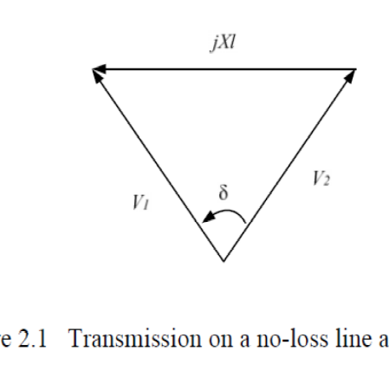

Without Compensation:-
AC system mainly consists of inductive load so it requires reactive power for its operation and hence, the source must supply it, increasing the current from the generator and through power lines, if reactive power is supplied near the load, the line current can be reduced or minimized resulting into lower losses and improving voltage regulation at the load terminals

3.4 Series Compensation:-

The conventional Series compensators employ switches to add inductive or capacitive reactance in transmission line. The conventional compensator emulates a static flow controller by means of mechanical switching. Series compensation can also be implemented by injecting a voltage source in series with transmission line as shown in Fig.
The voltage source can inject voltage of controllable magnitude and phase. When the injected voltage is in phase quadrature leading to line current, series compensation emulates like an inductor, similarly when injected voltage is lagging to line current it emulates a capacitor. The results obtained with the series compensation through a voltage source, which
Has been adjusted again to have unity power factor operation at V2 as shown in Fig.2.5. In
This case, voltage VCOMP has been added between the line and the load to change the angle
Of V2, which is now the voltage at the load side. As it can be seen from the phase diagram of Fig, VCOMP generates a voltage with opposite direction to the voltage drop in the line
Inductance because it lags the current IP.

3.5 Shunt Compensation:-

Shunt compensation is used to influence the natural electrical characteristics of the transmission line to increase the steady-state transmittable power and to control the voltage profile along the line. The shunt compensator like STATCOM can be operated either to provide capacitive or inductive compensation depending on the specific requirement. The impedance of the shunt controller, which is connected to the line voltage, causes a variable current flow, and hence represents an injection of current into the line. As long as the injected
Current is in phase quadrature with the line voltage, the shunt controller only supplies or

Consumes variable reactive power. The ultimate objective of applying reactive shunt compensation in a transmission system is to increase the transmittable power capability from the generator to the load, which is required to improve the steady-state transmission characteristic as well as the stability of the system.

The main purpose of shunt compensation is to provide the following:
• Steady state and dynamic voltage control.
• Reactive power control of dynamic loads.
• Damping of active power oscillations.
• Improvement of system stability

Series Compensators:-
The series Compensator could be variable impedance, such as capacitor, reactor, etc., or power electronics based variable source of main frequency to serve the desired need.

Various Series connected FACTS devices are:
1) Thyristor Controlled Series Capacitor (TCSC).
2) Thyristor Switched Series Capacitor (TSSC).
3) Thyristor Controlled Series Reactor (TCSR).
4) Thyristor Switched Series Reactor (TSSR).
5) Static Synchronous Series Compensator (SSSC).

Shunt Compensators:-
Shunt Controllers may be variable impedance, variable source, or a combination of these. In principle, all shunt Controllers inject current into the system at the point of connection. Various shunt connected controllers are:

1) Static Synchronous Compensator (STATCOM).
2) Static VAR Compensator (SVC).

\

CHAPTER-4

4. STATIC SYNCHRONOUS COMPENSATOR

4.1 INTRODUCTION
STATCOM is made up of a coupling transformer, a VSC and a dc energy storage device. STATCOM is capable of exchanging reactive power with the transmission line because of its small energy storage device i.e. small dc capacitor, if this dc capacitor is replaced with dc storage battery or other dc voltage source, the controller can exchange real and reactive power with the transmission system, extending its region of operation from two to four quadrants. A functional model of a STATCOM is shown in Fig.4.1.

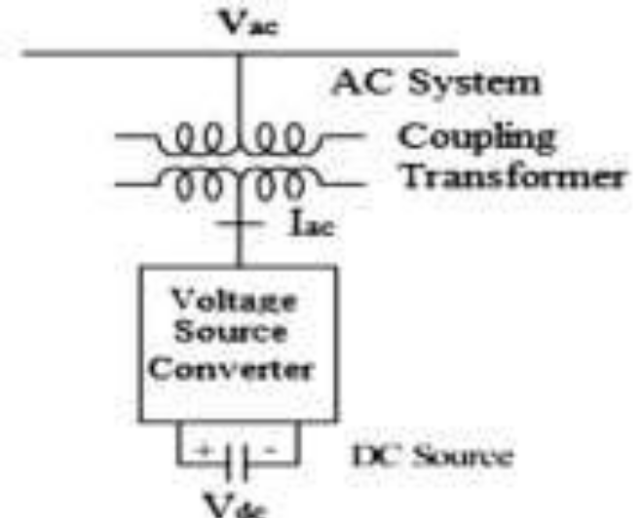

Fig.4.1 Basic Operation of STATCOM
STATCOM is a controlled reactive-power source. It provides the desired reactive-power generation and absorption entirely by means of electronic processing of the voltage and current waveforms in a voltage-source converter (VSC).

A single-line STATCOM power circuit is shown in Fig. 3.1, where a VSC is connected- to a utility bus through magnetic coupling. In Fig. 4.1, a STATCOM is seen as an adjustable voltage source behind a reactance—meaning that capacitor banks and shunt reactors are not needed for reactive-power generation and absorption, thereby giving a STATCOM a compact design, or small footprint, as well as low noise and low magnetic impact. The exchange of reactive power between the converter and the ac system can be controlled by varying the amplitude of the 3-phase output voltage, Es, of the converter.

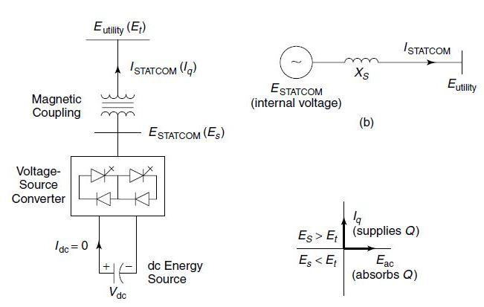

Fig 4.1.1 STATCOM block diagram

That is, if the amplitude of the output voltage is increased above that of the utility bus voltage, /Et/, then current flows through the reactance from the converter to the ac system and the converter generates capacitive-reactive power for the ac system. If the amplitude of the output voltage is decreased below the utility bus voltage, then the current flows from the ac system to the converter and the converter absorbs inductive-reactive power from the ac system. If the output voltage equals the ac system voltage, the reactive-power exchange becomes zero, in which case the STATCOM is said to be in a floating state.
Adjusting the phase shift between the converter-output voltage and the ac system voltage can similarly control real-power exchange between the converter and the ac system.
In other words, the converter can supply real power to the ac system from its dc energy storage if the converter-output voltage is made to lead the ac-system voltage. On the other hand, it can absorb real power from the ac system for the dc system if its voltage lags behind the ac-system voltage. A STATCOM provides the desired reactive power by exchanging the instantaneous reactive power among the phases of the ac system. The mechanism by which the converter internally generates and/ or absorbs the reactive power can be understood by considering the relationship between the output and input powers of the converter. The converter switches connect the dc-input circuit directly to the ac-output circuit. Thus the net instantaneous power at the ac output terminals must always be equal to the net instantaneous power at the dc- input terminals (neglecting losses).

Assume that the converter is operated to supply reactive-output power. In this case, the real power provided by the dc source as input to the converter must be zero. Furthermore, because the reactive power at zero frequency (dc) is by definition zero, the dc source supplies no reactive power as input to the converter and thus clearly plays no part in the generation of reactive-output power by the converter.

However, to not violate the instantaneous power-equality constraint at its input and output terminals, the converter must draw a fluctuating current from its dc source. Depending on the converter configuration employed, it is possible to calculate the minimum capacitance required to meet the system requirements, such as ripple limits on the dc voltage and the rated-reactive power support needed by the ac system. The VSC has the same rated-current capability when it operates with the capacitive- or inductive-reactive current. Therefore, a VSC having a certain MVA rating gives the STATCOM twice the dynamic range in MVAR (this also contributes to a compact design).

4.2 The V-I Characteristic:-

A typical V-I characteristic of a STATCOM is depicted in Fig. 3.2. As can be seen, the STATCOM can supply both the capacitive and the inductive compensation and is able to independently control its output current over the rated maximum capacitive or inductive range irrespective of the amount of ac-system voltage. That is, the STATCOM can provide full capacitive-reactive power at any system voltage—even as low as 0.15 pu. The characteristic of a STATCOM reveals strength of this technology: that it is capable of yielding the full output of capacitive generation almost independently of the system voltage (constant-current output at lower voltages). This capability is particularly useful for situations in which the STATCOM is needed to support the system voltage during and after faults where voltage collapse would otherwise be a limiting factor.

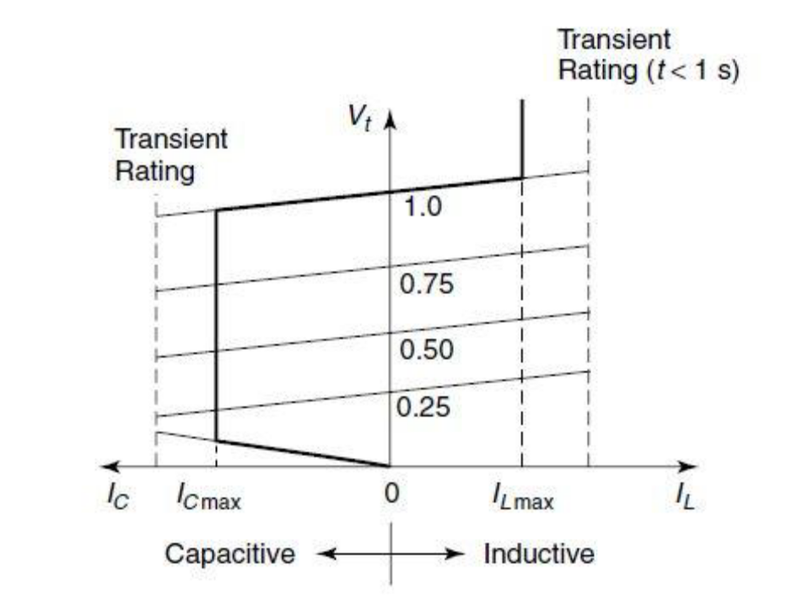

Fig 4.2 V-I characteristic of STATCOM

Figure 3.2 also illustrates that the STATCOM has an increased transient rating in both the capacitive- and the inductive-operating regions. The maximum attainable transient overcurrent in the capacitive region is determined by the maximum current turn-off capability of the converter switches. In the inductive region, the converter switches are naturally commutated; therefore, the transient-current rating of the STATCOM is limited by the maximum allowable junction temperature of the converter switches. In practice, the semiconductor switches of the converter are not lossless, so the energy stored in the dc capacitor is eventually used to meet the internal losses of the converter, and the dc capacitor voltage diminishes.

However, when the STATCOM is used for reactive-power generation, the converter itself can keep the capacitor charged to the required voltage level. This task is accomplished by making the output voltages of the converter lag behind the ac-system voltages by a small angle (usually in the 0.18–0.28 range). In this way, the converter absorbs a small amount of real power from the ac system to meet its internal losses and keep the capacitor voltage at the desired level. The same mechanism can be used to increase or decrease the capacitor voltage and thus, the amplitude of the converter-output voltage to control the var generation or absorption.

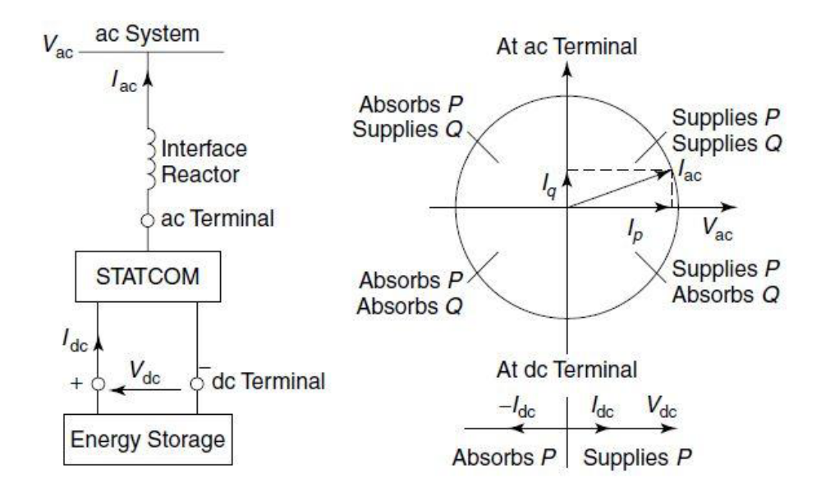

Fig 4.2.1 one line Diagram of STATCOM

With the continuous need for safe, reliable and quality electricity supply, more versatile methods of power generation are being implemented world-wide. Two technically challenging concepts to achieve the above stated goal are stated here. Firstly, renewable energy sources are made use of, due to the rising problems with the conventional fossil fuels and environmental factors. Secondly, a custom power device such as STATCOM is used as an interfacing unit between grid, load and renewable energy source. The renewable energy source and STATCOM unit are driven by a simple algorithm called modified Icosφ algorithm, which provides the necessary reactive power compensation, power factor correction and also control of real power flow from the source (grid) and renewable energy.

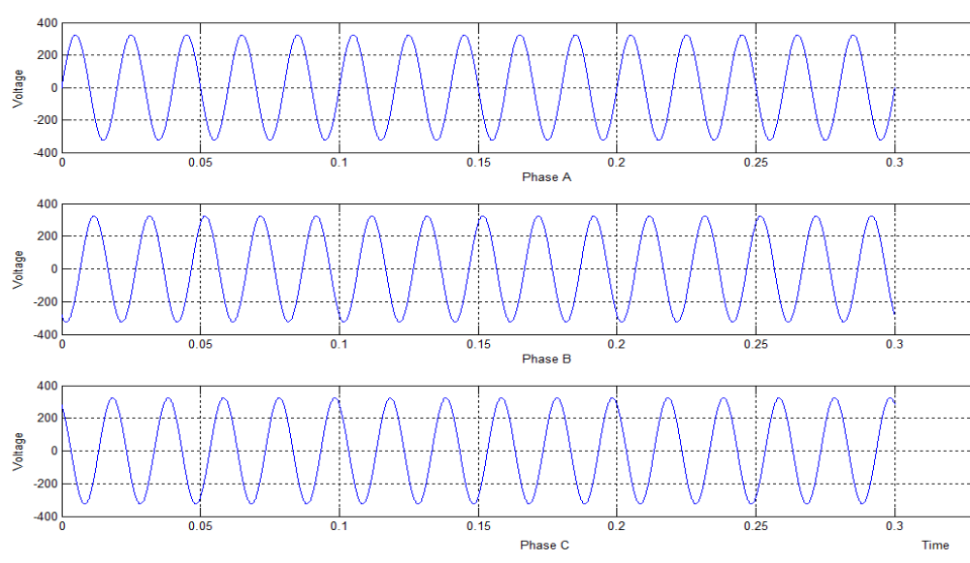

.fig 4.2.2.Three phase voltages source (grid) side

CHAPTER-5

5. MODULAR MULTILEVEL INVERTER

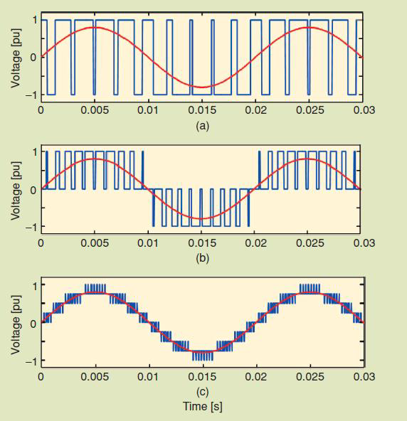

Fig 5.1.output phase voltage waveforms (a) two-level inverter, (b) three-level, (c) nine-level

Multi-pulse operation is achieved, by connecting identical three-phase bridges, Fig.5.1 to transformers which have outputs that are phase-displaced with respect to one another. Star and delta-connected windings have a relative 30 phase shift and a 6-pulse converter bridge connected to each transformer will give an overall 12-pulse operation eliminating 5th and 7th harmonics. This principle can be extended to 24- and 48-pulse operation summing at the primary windings the transformed outputs of several 6-pulse converters (4 for 24-pulse and 8 for 48-pulse operation).
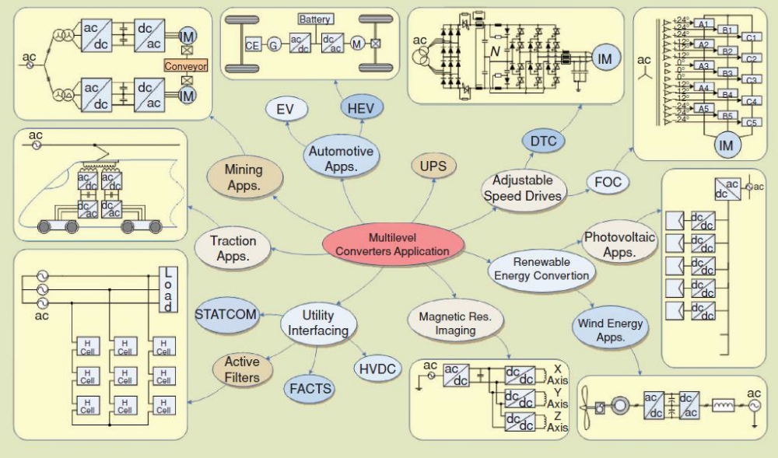

Fig 5.1.1Multilevel inverter driven application overview

Three major multilevel inverter structure which has been mostly applied in industrial application have been emphasized as the diode clamp, the flying capacitor and cascade H-bridge inverter with separated DC sources. Based on these three basic types, a hybrid and an asymmetric hybrid has been developed. Figure 3 shows common multilevelinverter types. From this three types, Diode Clamp (DC) inverters and cascaded inverters are mostpopular. DC inverter used in high power area, mainly are three level inverter.

Comparing with two level inverter, DC three level inverters have economic advantages. A multilevel inverter type with less power devices requirement compared to previously mentioned types is known as cascaded H-bridge multilevel inverter (CHB-MLI) and the type is based on the series connection of H-bridge with separate DC source. Since the output terminals of the H-bridges are connected in series, the DC source must be isolatedfrom each other. This topology is a good choice for more than five-level output waveform. Cascade inverter have structurally no problem of dc-link voltage unbalancing

5.1 Merit and Demerit of Multilevel Inverter

Obviously, in recent years multilevel inverter has gained an attention from many areas due to its advantages over the conventional inverters. The ability of the multilevel inverter to utilize a large number of dc sources is one of the merits that it holds. This makes multilevel inverters able to generate high voltages and thus high power ratings.

Due to this, the use of bulky and expensive transformers to produces high voltages with conventional 12, 24 and 48-pulse inverter can be abandoned.

Another advantage of multilevel inverter is that it has a reduced Total Harmonic Distortion (THD) with low switching frequencies. Furthermore, due to its lowervoltage steps, the value of EMI is lesser and because of its capability to utilize multiple levels on the dc bus, the multilevel inverters able to trim down the voltage stress on each power devices. Additionally, multilevel inverters have higher efficiency because the devices can be switched at low frequency.

5.2. The Switching

There are many ways and techniques have been developed to control multilevel inverter switching, from the very basic fundamental switching up to the most advance space vector pulse width modulation switching scheme. But, the most famous and applied by industries out there is the PWM switching control scheme .PWM switching control scheme comes with advantages over the traditional multilevel fundamental switching scheme.

One benefit of PWM methods employing much higher switching frequencies Concerns harmonics. The harmonics filtering exercise is much easier and cheaper due to the fact that the undesirable harmonics occur at much higher switching frequencies. Also, the produced harmonics might be above the bandwidth of some actual system. This means that there is no power dissipation caused by the harmonics. On the contrary, multilevel fundamental switching scheme creates harmonics at lower switching frequencies and this increased the complexity of the filtering activity.

5.3 Control Techniques

Multilevel inverter parameter quality such as switching losses and harmonic reduction are basically depends on the modulation strategies applied to the inverter. Several modulation and control techniques have been developed for multilevel inverters. As shown in Figure 1.4, control technique for the multilevel inverter cab be classified into PWM, Selective Harmonic Elimination PWM (SHEPWM) and Optimized Harmonics Stepped Waveform (OHSM). PWM can be classified to open loop and closed loop. For this research, open loop modulation is proposed which will focus onSinusoidal PWM (SPWM).

5. 4 Problem Statements

One of the important components in the system is the inverter which converts the
DC energy stored in the battery banks to AC energy which will then use by consumer or connected to power grid. As the current trend required cleaner power source, higher output power, less losses and almost free harmonics, people are looking forward for better inverter. Thus, a conventional single level inverter is no more relevant to cope with the current trend. Nowadays, industries, researches are focusing to come out with inverter that can overcome the above mentioned issues.As a result a multilevel inverter is created and first published by Nabbed in 1980s.

The best performance on higher level of inverter and a promising result on Third
Harmonic Injection PWM control technique over SPWM become a motivation for the proposed research. Based on the simulation and several experiment done by previous Line voltage waveform for a six-level diode-clamped inverter as the level of inverter increases, the degree of complexity once-MLI and FC-MLI hardware is also higher.

Now, modern industrial devices are mostly based on electronic devices that are very sensitive to harmonics, even for the induction motor whereby extra heat will be generated with higher harmonic level.

Therefore, the proposed work is believed shall synthesize a better quality result with Third harmonic Injection PWM scheme but with better topology which required lessercomponents and hardware complexity in hardware development.

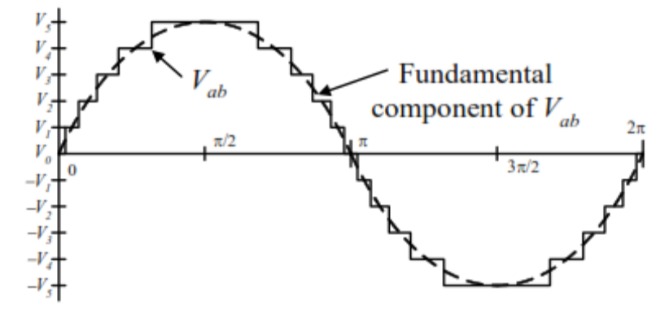

Fig 5.4 .Harmonic wave

The harmonic cancellation is carried out into the transformer secondary windings. The basic issue in structuring a high-power, multi-pulse converter is the complexity of the magnetic structure that is needed. The converter operation is carried out applying low frequency (usually line frequency) firing pulse to the power switches.

Due to switching frequency, only about one third of the converter losses are due to the
Switching losses, the remaining two thirds are due to the magnetic interface (conduction Losses). A typical multi-pulse waveform is depicted in Fig. 5.4.1

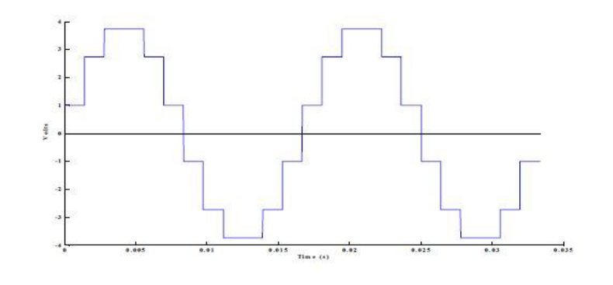

Fig.5.4.1 multiphase waveform

5.5 Three Phase 48 Pulse GTO Converter: -

Here ideal switches and zigzag phase shifting transformers are used to build a GTO-type 100 MVA, 138 kV voltage source inverter. This type of converter is used in high-power (up to 200 MVA) Flexible AC Transmission Systems (FACTS) which are used to control power flow on transmission grids. 48-pulse GTO converter described in reference. It consists of four 3-phase, 3-level inverters and four phase-shifting transformers. Here DC bus (Vdc = +/-9650 V) is connected to the four 3-phase inverters. The four voltages generated by the inverters are applied to secondary windings of four zigzag phase-shifting transformers connected in Wye (Y) or Delta (D).

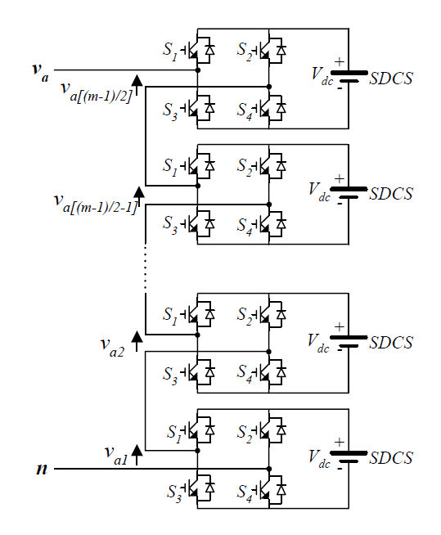

Fig. 5.5 M-Level Single Phase Cascaded H-Bridge Multilevel Inverter

Each 3-level inverter generates three square-wave voltages which can be +Vdc, 0, -Vdc. The duration of the +Vdc or -Vdc level (Sigma) can be adjusted between 0 and 180 degrees from the Sigma input of the Firing Pulse Generator block. Each inverter uses a Three-Level Bridge block where specified power electronic devices are Ideal Switches. In
This model each leg of the inverter uses 3 ideal switches to obtain the 3 voltage levels (+Vdc, 0, - Vdc). This simple model simulates the behaviour of a physical inverter where each leg consists of 4 GTOs, 4 antiparallel diodes and 2 neutral clamping diodes. Despite this simplified switch arrangement, the model still requires 4 pulses per arm as in the physical model. The phase shifts produced by the secondary delta connections (-30 degrees) and by the primary zigzag connections (+7.5 degrees for transformers 1Y and 1D, and -7.5 degree for transformers 2Y and 2D) allows to neutralize harmonics up to 45th harmonic, as explained below:

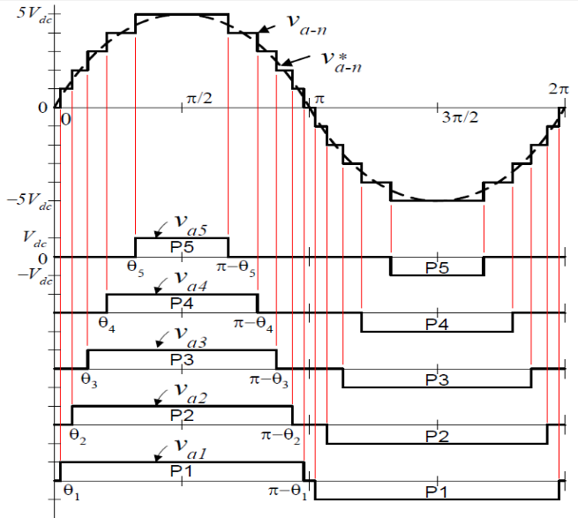

Figure: 5.5.1 Cascaded H-Bridge Multilevel Inverter Generalize Output Waveform

Multilevel cascaded inverters have been proposed for such applications as static var generation, an interface with renewable energy sources, and for battery-based applications. Three-phase cascaded inverters can be connected in wye, as shown in Figure, or in delta. Pang has demonstrated a prototype multilevel cascaded static-var generator connected in parallel with the electrical system that could supply or draw reactive current from an electrical system [20-23]. The inverter could be controlled to either regulate the power factor of the current drawn from the source or the bus voltage of the electrical system where the inverter was connected. Peng [20] and Joos [24] have also shown that a cascade inverter can be directly connected in series with the electrical system for static var compensation. Cascaded inverters are ideal for connecting renewable energy sources with an ac grid, because of the need for separate dc sources, which is the case in applications such as photovoltaic or fuel cells

Cascaded inverters have also been proposed for use as the main traction drive in electric vehicles, where several batteries or ultra-capacitors are well suited to serve as SDCSs [19, 26]. The cascaded inverter could also serve as a rectifier/charger for the batteries of an electric vehicle while the vehicle was connected to an ac supply as shown in Figure 5.2. Additionally, the cascade inverter can act as a rectifier in a vehicle that uses regenerative braking.

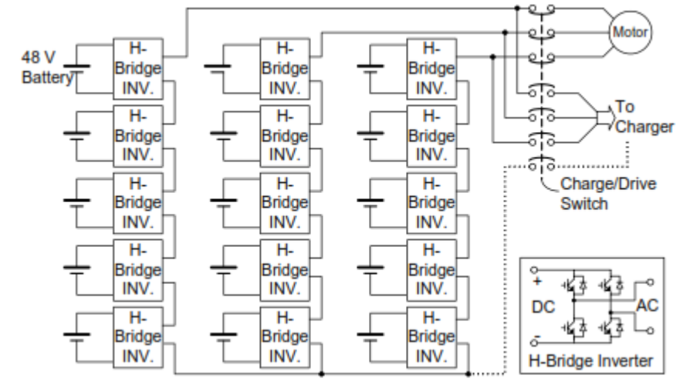

Figure 5.5.2 3ph multilevel converter

Three-phase Manjrekar has proposed a cascade topology which instead of being identical in value are multiples of each other [27-28]. He also uses a combination of fundamental frequency switching for some of the levels and PWM switching for part of the levels to achieve the output voltage waveform. This approach enables a wider diversity of output voltage magnitudes; however, it also results in unequal voltage and current ratings for each of the levels and loses the advantage of being able to use identical, modular units for each leveled wye-connection structure for electric vehicle motor drive and battery charging.

The 30-degree phase-shift between the Y and D secondary’s cancels harmonics 5+12n (5, 17, 29, 41,) and 7+12n (7, 19, 31, 43,). In addition, the 15-degree phase shift between the two groups of transformers (1Y and 1D leading by 7.5 degrees, 2Y and 2D lagging by +7.5 degrees) allows cancellation of harmonics 11+24n (11, 35, ...) and 13+24n (13, 37, ...). Considering that all 3n the harmonics are not transmitted by the Y and D secondary’s, the first harmonic which are not cancelled by the transformers are 23rd, 25th, 47th and 49th.

Advantages:

- The number of possible output voltage levels is more than twice the number of dc sources (m = 2s + 1).
- The series of H-bridges makes for modularized layout and packaging. This will enable the manufacturing process to be done more quickly and cheaply

Another kind of cascaded multilevel converter with transformers using standard three phase bi-level converters has been proposed [14]. The circuit is shown in Figure 5. 2.
The converter uses output transformers to add different voltages. In order for the converter output voltages to be added up, the outputs of the three converters need to be synchronized with a separation of 120° between each phase. For example, obtaining a three-level voltage between outputs a and b, the output voltage can be synthesized by An isolated transformer is used to provide voltage boost.With three converters synchronized, the voltages V

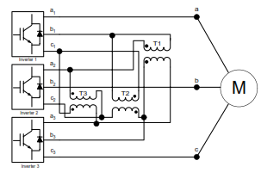

Figure 5.5.3. Cascaded multilevel converter with transformers using standard three-phase bi-level converters

5.5.1Waveforms & Results: -

When the inverter is operating at no load, you can observe the three 48-step voltage waveform. When the load is switched on the voltage becomes smoother because harmonics are filtered by the transformer leakage reactance.

5.6 Pulse Width Modulation: -

In multi-pulse and multi-level converters, there is only one turn-on, turn-off per device per cycle. Another approach is to have multiple pulses per half-cycle, and then vary the width of the pulses to vary the amplitude of the AC voltage.
The pulse width modulation (PWM) technique is commonly employed to generate high quality output waveforms by relatively low power converter used in variable frequency AC motor drives and distribution applications. With this technique, the output of each converter pole is switched several times during a fundamental cycle between the positive and negative terminals of the DC source. PWM requires a considerable increase in the number switch operations (high switching frequency); thereby it generally increases the switching losses of the converter [1, 5, and 6]. However, the always increasing switching frequency of modern solid-state power switches could make possible the use of PWM in high power applications. Among the various VSI topologies the multi-pulse configurations and the multi-level configuration have become popular for advanced Static VAR compensation applications.

In these configurations the switching frequency can be kept low in order to minimise device stresses switching losses and electromagnetic interference. Some commercials STATCOM installed are:

The STATCOM installed in Japan in 1991 uses eight six-pulse VSI, each of 10 MVA rating, connected to a main transformer resulting in 48-pulse STATCOM. A 100 MVA 48-pulse STATCOM was installed in 1995 for the Tennessee Valley Authority (TVA) at the Sullivan Substation in North-Eastern Tennessee.

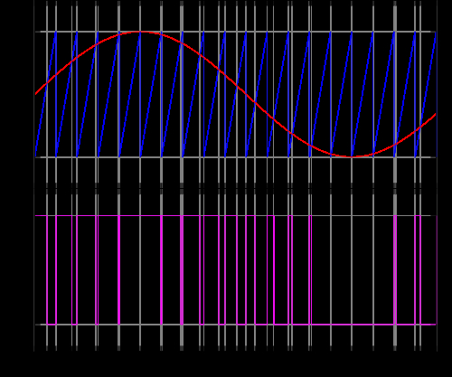

Fig 5.6 Waveform Pulse width modulation

The simplest way to generate a PWM signal is the interceptive method, which requires only a saw tooth or a triangle waveform (easily generated using a simple oscillator) and a comparator. When the value of the reference signal (the red sine wave in figure 2) is more than the modulation waveform (blue), the PWM signal (magenta) is in the high state, otherwise it is in the low state.

5.7- Pulse Operation: -

Two 24-pulse converters, phase-shifted by 7.5◦ from each other, can provide a 48-pulse converter. Using a symmetrical criterion the 7.5◦ are provided in the following way: phase-shift windings with -3.75◦ on the two transformers of one 24-pulse converter, and +3.75◦ on the two transformers of the other one. The firing pulse needs a phase-shift of +3.75◦ and –3.75◦, respectively. The 48-pulse converter is comprised by four 12-pulse converter linked by four 12-pulse transformers with phase-shift windings (see Fig.5.3). Fig.3.10 depicts the schematic diagram of a 48-pulse STATCOM. The transformer connexion and the necessary firing pulse logic to get the 48-pulse operation will be treated in the next section.

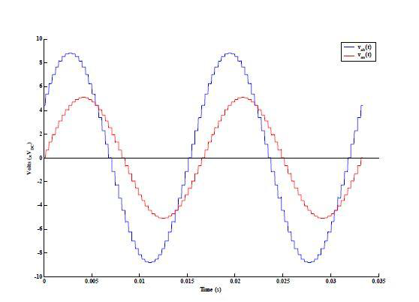
Fig.5.7-pulse voltage

CHAPTER-6

6. MATLAB MODEL& SIMULATION

6.1 Introduction: -

The example described in this section illustrates application of Simulation of Power Systems software to study the steady-state and dynamic performance of a static synchronous compensator (STATCOM) on a transmission system. The STATCOM is a shunt device of the Flexible AC Transmission Systems (FACTS) family using power electronics. It regulates voltage by generating or absorbing reactive power.

If you are not familiar with the STATCOM, please refer to the Static Synchronous Compensator (Phasor Type) block documentation, which describes the STATCOM principle of operation. Depending on the power rating of the STATCOM, different technologies are used for the power converter.

High power STATCOMs (several hundreds of Mvars) normally use GTO-based, square-wave voltage-sourced converters (VSC), while lower power STATCOMs (tens of Mvars) use IGBT-based (or IGCT-based) pulse-width modulation (PWM) VSC. The Static Synchronous Compensator (Phasor Type) block of the FACTS library is a simplified model, which can simulate different types of STATCOMs. You can use it with phasor simulation, available through the Powerful block, for studying dynamic performance and transient stability of power systems. Due to low frequencies of electromechanical oscillations in large power systems (typically 0.02 Hz to 2 Hz), this type of study usually requires simulation times of 30–40 seconds or more. The STATCOM model described in this example is rather a detailed model with full representation of power electronics. It uses a square-wave, 48-pulse VSC and interconnection transformers for harmonic neutralization.

This type of model requires discrete simulation at fixed type steps (25 μs in this case) and it is used typically for studying the STATCOM performance on a much smaller time range (a few seconds). Typical applications include optimizing of the control system and impact of harmonics generated by converter.

6.2 STATCOM power component: -

The STATCOM consists of a three-level 48-pulse inverter and two series-connected 3000 μF capacitors which act as a variable DC voltage source. The variable amplitude 60 Hz voltage produced by the inverter is synthesized from the variable DC voltage which varies around 19.3 kV. The STATCOM uses this circuit to generate the inverter voltage V2 voltage mentioned in the Static Synchronous Compensator (Phasor Type) block documentation. It consists of four 3-phase 3-level inverters coupled with four phase shifting transformers introducing phase shift of +/-7.5 degrees.

Except for the 23rd and 25th harmonics, this transformer arrangement cancel harmonics 5+12n (5, 17, 29, 41,) and 7+12n (7, 19, 31, 43,). In addition, the 15° phase shift between the two groups of transformers (Tr1Y and Tr1D leading by 7.5°, Tr2Y and Tr2D lagging by 7.5°) allows cancellation of harmonics 11+24n (11, 35,...) and 13+24n (13, 37,...).

Considering that all 3n harmonics are not transmitted by the transformers (delta and ungrounded Y), the first harmonics that are not cancelled by the transformers are therefore the 23rd, 25th, 47th and 49th harmonics. By choosing the appropriate conduction angle for the three-level inverter (σ = 172.5°), the 23rd and 25th harmonics can be minimized. The first significant harmonics generated by the inverter will then be 47th and 49th. Using a bipolar DC voltage, the STATCOM thus generates a 48-step voltage approximating a sine wave.

6.3 STATCOM Control System: -

The control system task is to increase or decrease the capacitor DC voltage, so that the generated AC voltage has the correct amplitude for the required reactive power. The control system must also keep the AC generated voltage in phase with the system voltage at the STATCOM connection bus to generate or absorb reactive power only (except for small
Active power required by transformer and inverter losses).

The control system uses the following modules:

- PLL (phase locked loop) synchronizes GTO pulses to the system voltage and provides a reference angle to the measurement system.
- Measurement System computes the positive-sequence components of the STATCOM voltage and current, using phase-to-dq transformation and a running-window averaging.
- Voltage regulation is performed by two PI regulators: from the measured voltage Vmeas and the reference voltage Vref, the Voltage Regulator block (outer loop) computes the reactive current reference Iqref used by the Current Regulator block (inner loop). The output of the current regulator is the angle which is the phase shift of the inverter voltage with respect to the system voltage. This angle stays very close to zero except during short periods of time, as explained below.

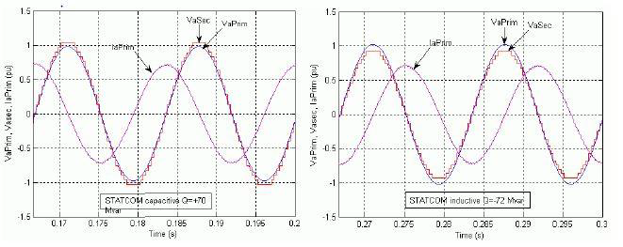

Fig. 6.3 Capacitive & Inductive mode Compensation

CHAPTER-7

7. SIMULATION & RESULT

7.1 SIMULATION 0F 3PH FAULT CONDITION WITHOUT STATCOM
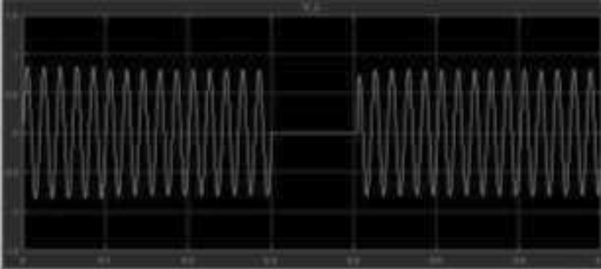

Fig 7.1 Source Voltage in 3 Phase Fault condition without STATCOM

7.2 SIMULATION OF 3PH FAULT CONDITION WITH STATCOM

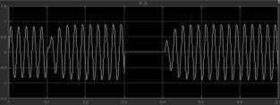

Fig.7.2 Source Voltage in 3 Phase Fault condition with STATCOM

7.3 SIMULATION OF LL FAULT CONDITION WITH STATCOM

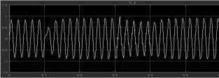

Fig.7.3 Source Voltage in LL Fault condition with STATCOM

7.4 SIMULATION OF LLG FAULT CONDITION WITH STATCOM

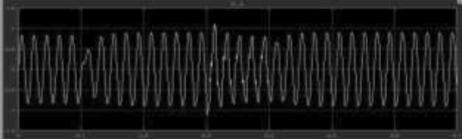

Fig.7.4 Source Voltage in LLG Fault condition with STATCOM

7.5 Project Scopes

The scopes of this project are:
- This research will be focus on the way to development of 9 level multilevel inverter.
- Implementation of Cascade H-Bridge MLI type and Third harmonic Injection PWM control technique.
- Studies on improvement of total harmonic distortion among other level of harmonic injection levels.

CHAPTER-8

CONCLUSION

In this Project a full-bridge MMC converter based STATCOM model is implemented and stimulated with PSPWM scheme. In this system, the SM capacitor voltages are balanced by two control loops, one equalizes the capacitor energy among three phases, and the other balances the capacitor voltage within each arm. This scheme has fast response and minimum impact on the STATCOM voltage and current harmonics. The MMC STATCOM and its controller are validated in a test system for scenarios, i.e. the steady state, voltage sag, 3-phase-ground ac fault and the obtained results shows the proposed control scheme is effective and robust. The STATCOM has fast response to voltage sag, and fast recovery after ac or dc faults, even without protection circuits.

REFERENCES
1. H. Akagi, “Classification, terminology, and application of the modular multilevel cascade converter (MMCC),” IEEE Trans. Power Electronics,vol. 26, no. 11, pp. 3119–3130, Nov. 2011.
2. J. S. Lai and F. Z. Peng , “Multilevel converters-A new breed of power converters,” IEEE Trans. Ind. Appl., vol. 32, no. 3, pp. 509–517, May/Jun. 1996.

3.F. Z. Peng and J. S. Lai, “Dynamic performance and control of a static var generator using multilevel inverters,” IEEE Trans. Ind. Appl., vol. 33, no. 3, pp. 748–755, May/Jun. 1998.

4. Y. Liang and C. O. Nwankpa, “A new type of STATCOM based on cascading voltage-source inverters with phase-shifted unipolar SPWM”, IEEE Trans. Ind. Appl, vol. 35, no. 5, pp. 1118–1123, Sep./Oct. 1999.

5 S. Sirisukprasert, A.Q. Huang, “Modeling analysis and control of cascaded-multilevel converter-based STATCOM,” in Proc. Power Eng. Soc. Gen. Meeting, 2003, pp. 13–17.

6. C.K. Lee, J. S. K. Leung, S. Y. R. Hui, and H. S. H. Chung, “Circuitlevel comparison of STATCOM technologies,” IEEE Trans. Power Electron., vol. 18, no. 4, pp. 1084–1092, Jul. 2003.

7. F. Z. Peng and J. Wang, “A universal STATCOM with delta connected Cascade multilevel inverter,” in Conf. Rec. IEEE PESC, 2004, pp. 3529–3533.

8. H. Mohammadi Pirouzy and M. Tavakoli Bina “Modular Multilevel Converter Based STATCOM Topology Suitable for Medium-Voltage Unbalanced Systems”, Journal of Power Electronics, September 2010, Vol. 10, No. 5, pp. 1534 – 1545.

